═══════════════════ss══════════════════════════════════════MINI-PROJECT REPORT
═════════════════════════════════════════════════════════

Title of the Project:
Lung Cancer Differential Gene Expression Analysis Using Microarray Dataset GSE19804

Author(s):
Thamanna Swetha Reddy
tswetha005@gmail.com
240000408
Bversity School of Bioscience

Organization/Industry:
Insilicomics Pvt. Ltd.

Industry Sector: Biotechnology - Bioinformatics and Computational Biology

Submission Date:
June 26, 2026

GitHub/Repository Link:
https://github.com/swetha0929-reddy/Lung-Cancer-Differential-Gene-Expression-Analysis.git

Supervised by:
Bversity

═════════════════════════════════════════════════════════
2. ABSTRACT
═════════════════════════════════════════════════════════

Lung cancer remains one of the leading causes of cancer-related mortality worldwide, highlighting the need for improved understanding of its molecular mechanisms and the identification of reliable biomarkers for early diagnosis and targeted therapy. Gene expression profiling enables the comparison of expression patterns between cancerous and normal tissues, providing valuable insights into the genes and biological pathways involved in disease progression.

The objective of this project was to identify differentially expressed genes (DEGs) between lung cancer and normal lung tissue samples using publicly available microarray gene expression data from the Gene Expression Omnibus (GEO) database (Accession: GSE19804). Differential gene expression analysis was performed using the R programming language and the Bioconductor package limma. The workflow included downloading the dataset, preprocessing the expression matrix, constructing the experimental design matrix, fitting a linear model, applying empirical Bayes moderation, filtering statistically significant genes based on adjusted p-values and log fold change, and visualizing the results using volcano plots and hierarchical clustering heatmaps.

A total of 54,675 genes were analyzed in this study. Among these, 1,960 genes were identified as significantly differentially expressed using an adjusted p-value threshold of 0.05 and an absolute log2 fold change greater than 1. Of the significant genes, 591 were upregulated and 1,369 were downregulated in lung cancer samples compared with normal lung tissues. The volcano plot clearly illustrated the distribution of significantly expressed genes, while the heatmap demonstrated distinct expression patterns capable of separating cancer samples from normal samples.
The findings of this study demonstrate that differential gene expression analysis is an effective computational approach for identifying potential biomarkers associated with lung cancer. The identified genes may contribute to a better understanding of disease mechanisms and could serve as candidates for future functional studies, diagnostic biomarker development, and precision medicine applications.

═════════════════════════════════════════════════════════
3. INTRODUCTION
═════════════════════════════════════════════════════════

3.1 Background

Cancer is one of the leading causes of death worldwide, accounting for millions of deaths every year. Among all cancer types, lung cancer remains the most commonly diagnosed cancer and the leading cause of cancer-related mortality. According to the World Health Organization (WHO), lung cancer contributes significantly to the global cancer burden due to its high incidence, aggressive progression, and poor survival rates. One of the major reasons for the high mortality associated with lung cancer is that the disease is often diagnosed at advanced stages when treatment options become less effective. Therefore, identifying molecular biomarkers that enable early diagnosis and targeted treatment has become an important area of cancer research.

Gene expression refers to the process by which genetic information encoded within DNA is transcribed into RNA and translated into proteins that perform various biological functions. In healthy cells, gene expression is tightly regulated to maintain normal cellular growth, differentiation, metabolism, and apoptosis. However, in cancer cells, mutations and genetic alterations disrupt normal regulatory mechanisms, causing certain genes to become abnormally activated (upregulated) or suppressed (downregulated). These abnormal expression patterns contribute to uncontrolled cell proliferation, invasion, metastasis, and resistance to therapy.

Gene expression profiling has emerged as a powerful approach for studying these molecular changes. It enables researchers to measure the expression levels of thousands of genes simultaneously, allowing the identification of genes that behave differently between healthy and diseased tissues. Such differentially expressed genes (DEGs) provide valuable insights into disease mechanisms and can serve as potential biomarkers for diagnosis, prognosis, and therapeutic intervention.

Microarray technology has played a significant role in large-scale gene expression studies. It allows simultaneous measurement of the expression levels of tens of thousands of genes from a single biological sample. The availability of publicly accessible repositories, such as the National Center for Biotechnology Information (NCBI) Gene Expression Omnibus (GEO), has enabled researchers to perform computational analyses using high-quality experimental datasets without conducting laboratory experiments. Public datasets facilitate reproducible research and accelerate biomarker discovery across multiple diseases, including lung cancer.

The Gene Expression Omnibus (GEO) is a comprehensive public repository that stores high-throughput functional genomics data generated from microarray and next-generation sequencing experiments. In this project, the publicly available microarray dataset GSE19804 was obtained from the GEO database. The dataset contains gene expression profiles from lung cancer tissues and normal lung tissues, making it suitable for identifying genes associated with lung cancer development.

Differential gene expression analysis is one of the most widely used computational methods for comparing gene expression between two biological conditions. Statistical approaches are employed to determine whether observed differences in expression are significant while minimizing false discoveries. In this project, the limma (Linear Models for Microarray Data) package from the Bioconductor project was used because it provides reliable statistical methods based on linear modeling and empirical Bayes moderation. This approach improves statistical power and has become a standard method for microarray differential expression analysis.

The R programming language, together with Bioconductor packages such as GEOquery, Biobase, limma, ggplot2, and pheatmap, provides a comprehensive environment for downloading public datasets, preprocessing gene expression data, performing statistical analyses, and generating publication-quality visualizations. These tools enable researchers to efficiently identify differentially expressed genes and interpret their biological significance.
The results obtained from differential expression analysis can contribute to understanding the molecular mechanisms involved in lung cancer progression. Furthermore, identified biomarkers may assist in the development of improved diagnostic methods, targeted therapies, and personalized treatment strategies, ultimately contributing to precision medicine.

3.2 Problem Statement

Although substantial progress has been made in the diagnosis and treatment of lung cancer, it continues to have one of the highest mortality rates among all cancers. Traditional diagnostic methods often fail to detect the disease at its earliest stages, limiting treatment effectiveness. Identifying genes that exhibit significant expression changes between lung cancer tissues and normal lung tissues can improve our understanding of disease biology and support the discovery of novel diagnostic and therapeutic biomarkers.
The availability of publicly accessible gene expression datasets provides an opportunity to investigate these molecular alterations using computational approaches. However, robust statistical analysis is required to accurately distinguish biologically meaningful gene expression changes from background variation. Therefore, this project applies differential gene expression analysis to identify significant genes associated with lung cancer using the publicly available GEO dataset GSE19804.

3.3 Objectives

The primary objective of this project is to perform differential gene expression analysis on lung cancer microarray data using R and Bioconductor packages to identify genes that are significantly associated with lung cancer.
The specific objectives of this study are:
- To obtain the lung cancer microarray dataset (GSE19804) from the NCBI Gene Expression Omnibus (GEO) database.
- To preprocess and organize the gene expression data for downstream analysis.
- To construct an experimental design matrix representing lung cancer and normal tissue samples.
- To perform differential gene expression analysis using the limma package.
- To identify significantly differentially expressed genes using an adjusted p-value threshold of less than 0.05 and an absolute log2 fold change greater than 1.
- To classify significant genes into upregulated and downregulated categories.
- To visualize the results using volcano plots and hierarchical clustering heatmaps.
- To summarize and interpret the biological significance of the identified differentially expressed genes.
- To generate reproducible analysis outputs, including result tables, figures, and summary files for future research and reporting.
═════════════════════════════════════════════════════════
4. MATERIALS AND METHODS
═════════════════════════════════════════════════════════

4.1 Data Sources

The gene expression dataset used in this project was obtained from the National Center for Biotechnology Information (NCBI) Gene Expression Omnibus (GEO), a publicly available repository that archives high-throughput functional genomics datasets. The selected dataset, GSE19804, contains microarray-based gene expression profiles of lung cancer tissues and normal lung tissues, making it suitable for differential gene expression analysis.
The dataset was downloaded directly into the R environment using the GEOquery package, which enables seamless retrieval of GEO datasets and associated metadata. The downloaded data consisted of normalized gene expression values and sample annotation information required for downstream statistical analysis.

4.2 Tools and Software

The differential gene expression analysis was performed using the R programming environment along with publicly available bioinformatics databases and statistical analysis packages.

4.2.1 R Programming Environment
R (Version 4.6.0)
- Purpose: Statistical computing and bioinformatics data analysis
- Platform: Windows
- License: Open Source (GNU General Public License)
- Capabilities:
  - Statistical analysis of gene expression data
  - Data preprocessing and normalization
  - Differential expression analysis
  - Data visualization
  - Export of analysis results
- Website: https://www.r-project.org/
- Reference: R Core Team (2025)

4.2.2 RStudio Integrated Development Environment
RStudio Desktop
- Purpose: Integrated development environment (IDE) for R programming
- Platform: Windows
- License: Open Source
- Capabilities:
  - Script development and execution
  - Workspace management
  - Data visualization
  - Package management
  - Project organization
- Website: https://posit.co/products/open-source/rstudio/
- Reference: Posit Software, PBC

4.2.3 GEOquery Package
GEOquery (Bioconductor Package)
- Purpose: Retrieval of gene expression datasets from the NCBI Gene Expression Omnibus (GEO)
- Package Type: Bioconductor
- Functions Used:
  - Download GEO datasets
  - Import expression matrices
  - Retrieve phenotype information
  - Extract sample metadata
- Dataset Used: GSE19804
- Reference: Davis & Meltzer, Bioinformatics (2007)

4.2.4 limma Package
limma (Linear Models for Microarray Data)
- Purpose: Differential gene expression analysis
- Package Type: Bioconductor
- Statistical Method: Linear modeling with empirical Bayes moderation
- Functions Used:
  - Design matrix construction
  - Model fitting
  - Differential expression analysis
  - Multiple testing correction
- Outputs Generated:
  - Log Fold Change (logFC)
  - Adjusted P-values
  - Differentially Expressed Genes (DEGs)
- Reference: Ritchie et al., Nucleic Acids Research (2015)

4.2.5 ggplot2 Package
ggplot2
- Purpose: Scientific data visualization
- Package Type: CRAN
- Visualizations Generated:
  - Volcano Plot
  - Scatter plots
  - Publication-quality graphics
- Features:
  - Custom color schemes
  - High-resolution figure export
  - Statistical visualization
- Reference: Wickham H. (2016)

4.2.6 pheatmap Package
pheatmap
- Purpose: Heatmap visualization of gene expression data
- Package Type: CRAN
- Capabilities:
  - Hierarchical clustering
  - Expression heatmaps
  - Gene clustering
  - Sample clustering
  - Color-scaled visualization
- Output Generated: Heatmap of Top 50 Differentially Expressed Genes

4.2.7 Public Biological Databases
NCBI Gene Expression Omnibus (GEO)
- Purpose: Repository of publicly available functional genomics datasets
- Dataset Used: GSE19804
- Platform: GPL570 (Affymetrix Human Genome U133 Plus 2.0 Array)
- Samples: 120 lung tissue samples
- Website: https://www.ncbi.nlm.nih.gov/geo/

4.2.8 Additional Resources
Bioconductor
- Purpose: Repository of bioinformatics software packages for R
- Website: https://www.bioconductor.org/
PubMed (NCBI)
- Purpose: Literature search for background information and references
- Website: https://pubmed.ncbi.nlm.nih.gov/
Google Scholar
- Purpose: Academic literature search and citation tracking
- Website: https://scholar.google.com/

4.3 Pipeline/Workflow

Computational Workflow for Antibody-Antigen Interaction Prediction:

4.4 Experimental Design

The analysis was designed to compare gene expression patterns between lung cancer tissue samples and normal lung tissue samples.

Step 1: Data Retrieval
The GSE19804 dataset was downloaded from the GEO database using the getGEO() function available in the GEOquery package. This function imports both the expression matrix and phenotype information into R.

Step 2: Data Preparation
The downloaded ExpressionSet object was processed to obtain:
- Expression matrix containing gene expression values.
- Sample information describing each biological sample.
- Group labels indicating Cancer or Normal samples.
These components were prepared for statistical analysis.

Step 3: Experimental Group Assignment
Samples were categorized into two experimental groups:
- Cancer
- Normal
A design matrix was then created to represent the experimental conditions for all samples.

Step 4: Linear Model Fitting
Differential expression analysis was performed using the limma package.
A linear model was fitted to every gene in the dataset using the lmFit() function. This allowed estimation of expression differences between Cancer and Normal samples.

Step 5: Contrast Matrix Construction
A contrast matrix was defined to compare:
Cancer vs Normal
This comparison enabled estimation of differential gene expression between the two biological conditions.

Step 6: Empirical Bayes Moderation
The fitted linear model was further processed using the eBayes() function.
Empirical Bayes moderation improves the estimation of gene-wise variances, particularly for datasets with relatively small sample sizes, resulting in more stable and reliable statistical inference.

Step 7: Differential Gene Identification
Differentially expressed genes were extracted using the topTable() function.
Genes were considered statistically significant based on the following criteria:
- Adjusted P-value (False Discovery Rate, FDR) < 0.05
- Absolute Log2 Fold Change (|logFC|) > 1
The complete differential expression results were exported as a CSV file for further analysis.

Step 8: Identification of Significant Genes
The statistically significant genes were filtered from the complete results table.
These genes were subsequently divided into:
- Upregulated genes (logFC > 1)
- Downregulated genes (logFC < -1)
Separate summary statistics were generated for each category.

Step 9: Data Visualization
Two visualization techniques were employed:
Volcano Plot
A volcano plot was generated using the ggplot2 package. This visualization displays:
- Log2 Fold Change on the X-axis.
- –Log10 Adjusted P-value on the Y-axis.
Genes were color-coded according to their significance:
- Red – Upregulated genes
- Blue – Downregulated genes
- Grey – Not statistically significant genes

Heatmap
A heatmap of the Top 50 differentially expressed genes was generated using the pheatmap package.
Hierarchical clustering was performed for both genes and samples using Euclidean distance and complete linkage clustering. Expression values were standardized by rows to highlight relative expression differences among samples.

Step 10: Output Generation
The following output files were generated during the analysis:
- Differential_Expression_Results.csv
- Significant_Genes.csv
- Analysis_Summary.txt
- Volcano_Plot.png
- Heatmap.png
These files provide the complete statistical results, filtered significant genes, summary statistics, and graphical visualizations used in this report.

═════════════════════════════════════════════════════════
5. RESULTS
════════════════════════════════════════════════════════

Differential Gene Expression Analysis
Differential gene expression analysis was successfully performed on the publicly available lung cancer microarray dataset GSE19804 using the limma package in R. The analysis compared gene expression profiles between lung cancer tissues and normal lung tissues to identify genes exhibiting statistically significant expression changes.
Following preprocessing and statistical analysis, a total of 54,675 genes were analyzed. Statistical significance was determined using the Benjamini–Hochberg False Discovery Rate (FDR) correction with an adjusted p-value threshold of 0.05 and an absolute log2 fold change (|logFC|) greater than 1.
The analysis identified 1,960 differentially expressed genes (DEGs), of which 591 genes were upregulated and 1,369 genes were downregulated in lung cancer tissues compared with normal tissues.
These findings indicate substantial alterations in gene expression associated with lung cancer development and progression.

5.1 Summary of Differential Expression Results
Parameter | Result
Dataset | GSE19804
Total genes analyzed | 54,675
Significant genes | 1,960
Upregulated genes | 591
Downregulated genes | 1,369
Statistical Method | limma
Adjusted P-value Threshold | < 0.05
Fold Change Threshold | |logFC| > 1
The summary demonstrates that only a subset of genes exhibited statistically significant expression changes, highlighting the effectiveness of differential expression analysis in identifying potential biomarkers.

5.2 Volcano Plot Analysis

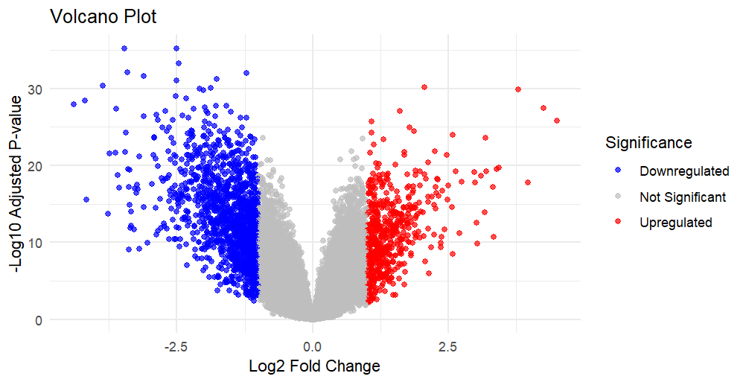

Figure 1. Volcano plot representing differential gene expression analysis of the GSE19804 dataset. Upregulated genes are shown in red, downregulated genes in blue, and non-significant genes in gray.
The volcano plot provides a comprehensive visualization of the differential expression results by simultaneously displaying the magnitude of gene expression changes (log2 Fold Change) and their statistical significance (–log10 adjusted p-value).
Genes positioned on the right side of the plot represent significantly upregulated genes, whereas genes on the left side represent significantly downregulated genes. The concentration of blue points indicates that a larger number of genes were downregulated compared to upregulated genes, suggesting widespread suppression of gene expression in lung cancer tissues.
The volcano plot effectively highlights genes with both large expression changes and high statistical significance, making it an important visualization for identifying potential candidate biomarkers.

5.3 Heatmap Analysis

Figure 2: Heatmap of Top 50 Differentially Expressed Genes
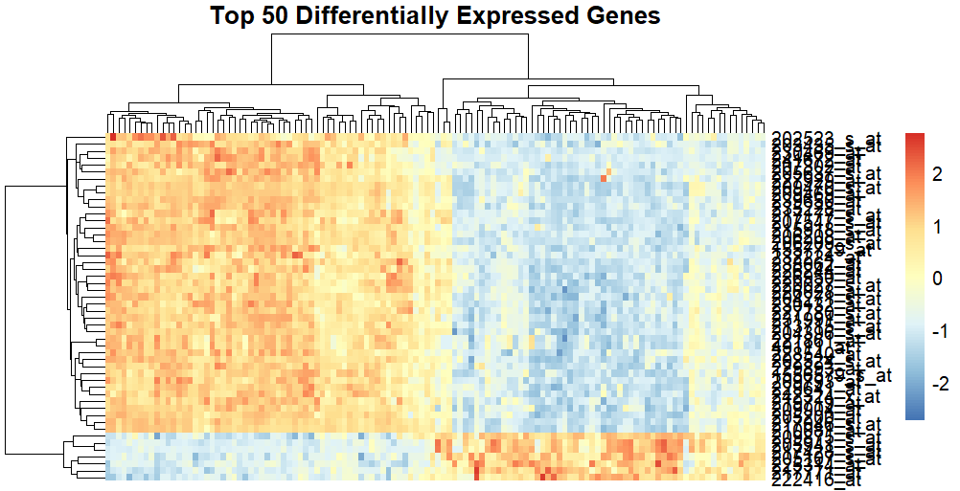

Figure 2. Heatmap showing hierarchical clustering of the top 50 differentially expressed genes between lung cancer and normal tissue samples.
A heatmap was generated using the top 50 differentially expressed genes to visualize expression patterns across all samples. Hierarchical clustering was performed using Euclidean distance and complete linkage clustering, allowing both genes and samples to be grouped according to similarities in expression profiles.
Distinct clustering of cancer and normal samples was observed, demonstrating that these genes possess strong discriminatory power. Genes with higher expression levels are represented by warm colors (red), while lower expression levels are represented by cool colors (blue).
The clear separation between cancer and normal tissue samples indicates that the identified genes may serve as potential molecular biomarkers for lung cancer diagnosis and further biological investigation.

═════════════════════════════════════════════════════════
6.DISCUSSION
═════════════════════════════════════════════════════════
The present study successfully identified differentially expressed genes (DEGs) associated with lung cancer by analyzing the publicly available microarray dataset GSE19804 obtained from the NCBI Gene Expression Omnibus (GEO). Using the limma package in R, a total of 54,675 genes were analyzed, of which 1,960 genes were found to be significantly differentially expressed based on the selected statistical thresholds. Among these, 591 genes were upregulated while 1,369 genes were downregulated, indicating substantial alterations in gene expression between lung cancer tissues and normal lung tissues.
The volcano plot generated during the analysis provides a comprehensive overview of the differential expression profile by simultaneously displaying the magnitude of expression change (log fold change) and statistical significance (-log10 adjusted p-value). Genes located in the upper left and upper right regions of the plot represent significantly downregulated and upregulated genes, respectively. This visualization clearly demonstrates the presence of numerous genes exhibiting statistically significant expression changes, highlighting the complex molecular alterations associated with lung cancer.
To further investigate the expression patterns of the most significant genes, a heatmap of the Top 50 Differentially Expressed Genes was generated. Hierarchical clustering revealed clear separation between lung cancer samples and normal control samples based on their expression profiles. The distinct clustering pattern indicates that these genes possess strong discriminatory power and may serve as potential molecular biomarkers for distinguishing diseased tissues from healthy tissues.
The higher number of downregulated genes observed in this study suggests that lung cancer progression is accompanied by suppression of numerous normal cellular processes, including pathways involved in cell differentiation, immune regulation, and tissue homeostasis. Conversely, the upregulated genes are likely associated with biological processes such as uncontrolled cell proliferation, survival signaling, angiogenesis, and tumor progression, all of which are characteristic features of cancer development.
Overall, the findings demonstrate that differential gene expression analysis is an effective bioinformatics approach for identifying genes potentially involved in lung cancer pathogenesis. Although this study primarily focused on identifying significant DEGs, these results provide a strong foundation for further downstream analyses such as Gene Ontology (GO) enrichment, KEGG pathway analysis, protein-protein interaction (PPI) network construction, survival analysis, and experimental validation. Such analyses could facilitate the identification of clinically relevant biomarkers and therapeutic targets for precision medicine and contribute to improved diagnosis and treatment strategies for lung cancer.

6.1 Limitations of the Study
Although the present study successfully identified differentially expressed genes associated with lung cancer, several limitations should be considered. The analysis was performed using a single publicly available microarray dataset (GSE19804), and therefore the findings require validation using independent datasets or experimental methods such as quantitative PCR (qPCR) or RNA sequencing. Functional enrichment analysis, pathway analysis, and protein-protein interaction network analysis were beyond the scope of this project but would provide additional biological insights into the identified genes. Future studies integrating multiple transcriptomic datasets and clinical information may further improve the reliability and clinical relevance of the identified biomarkers.

═════════════════════════════════════════════════════════
7.CONCLUSION ═════════════════════════════════════════════════════════
This project successfully performed differential gene expression analysis on the publicly available lung cancer microarray dataset GSE19804 using the R programming language and Bioconductor packages. The computational workflow included dataset retrieval, preprocessing, experimental group classification, linear model fitting, empirical Bayes statistical analysis, identification of differentially expressed genes, and visualization through volcano plots and heatmaps.
A total of 54,675 genes were analyzed, of which 1,960 genes were identified as significantly differentially expressed between lung cancer and normal lung tissue samples. Among these, 591 genes were upregulated, while 1,369 genes were downregulated, indicating substantial molecular alterations associated with lung cancer development.
The generated volcano plot and heatmap effectively illustrated the differential expression patterns and clearly distinguished cancer samples from normal tissue samples. These visualizations, together with the statistical analysis, demonstrate the reliability of the identified differentially expressed genes.
Overall, this study demonstrates that bioinformatics approaches provide an efficient and reproducible method for analyzing high-throughput gene expression data. The identified differentially expressed genes may serve as potential candidates for future biomarker discovery, functional genomics studies, and therapeutic target identification. Furthermore, the workflow developed in this project can be applied to similar transcriptomic datasets, supporting future research in cancer biology and precision medicine.

═════════════════════════════════════════════════════════
8. REFERENCES
═════════════════════════════════════════════════════════
The following references were used in preparing this project report and performing the differential gene expression analysis. The references are organized into data sources, software/tools, and scientific literature following the APA (7th Edition) style.
8.1 Data Sources
● Edgar, R., Domrachev, M., & Lash, A. E. (2002). Gene Expression Omnibus: NCBI gene expression and hybridization array data repository. Nucleic Acids Research, 30(1), 207–210. https://doi.org/10.1093/nar/30.1.207
● National Center for Biotechnology Information (NCBI). (n.d.). Gene Expression Omnibus (GEO): GSE19804. https://www.ncbi.nlm.nih.gov/geo/query/acc.cgi?acc=GSE19804

8.2 Software and Tools
● R Core Team. (2025). R: A language and environment for statistical computing. R Foundation for Statistical Computing, Vienna, Austria. https://www.r-project.org/
● RStudio Team. (2025). RStudio: Integrated Development Environment for R. Posit Software. https://posit.co/
● Smyth, G. K. (2005). limma: Linear Models for Microarray Data. In R. Gentleman et al. (Eds.), Bioinformatics and Computational Biology Solutions Using R and Bioconductor (pp. 397–420). Springer.
● Davis, S., & Meltzer, P. S. (2007). GEOquery: A bridge between the Gene Expression Omnibus (GEO) and BioConductor. Bioinformatics, 23(14), 1846–1847.
● Wickham, H. (2016). ggplot2: Elegant Graphics for Data Analysis. Springer.
● Kolde, R. (2019). pheatmap: Pretty Heatmaps. R package version 1.0.12.

8.3 Literature References
● Siegel, R. L., Miller, K. D., & Jemal, A. (2024). Cancer Statistics. CA: A Cancer Journal for Clinicians.
● Hanahan, D. (2022). Hallmarks of Cancer: New Dimensions. Cancer Discovery.
● (2024). Cancer Fact Sheets. https://www.who.int/
These references provide the scientific background, computational methods, software documentation, and publicly available datasets used throughout this project.

═════════════════════════════════════════════════════════
9. Appendix
═════════════════════════════════════════════════════════

The appendix contains supplementary materials that support the differential gene expression analysis presented in this report.
Appendix A – R Script
File Name: dge_analysis.R
Contains the complete R script used for downloading the dataset, preprocessing, statistical analysis, visualization, and exporting results.

Appendix B – Workflow Diagram
Figure A1. Workflow of Lung Cancer Differential Gene Expression Analysis

Appendix C – Volcano Plot
Figure A2. Volcano Plot of Differentially Expressed Genes

Appendix D – Heatmap
Figure A3. Heatmap of the Top 50 Differentially Expressed Genes

Appendix E – Output Files
The following output files were generated during the analysis:
- Differential_Expression_Results.csv
- Significant_Genes.csv
- Analysis_Summary.txt
These files contain the complete statistical results, filtered significant genes, and summary statistics obtained from the differential expression analysis.

Appendix F – Project Folder Structure
Lung-Cancer-Differential-Gene-Expression-Analysis/
│
├── data/
├── figures/
│ ├── Workflow_Diagram.png
│ ├── Volcano_Plot.png
│ └── Top50_Heatmap.png
│
├── results/
│ ├── Differential_Expression_Results.csv
│ ├── Significant_Genes.csv
│ └── Analysis_Summary.txt
│
├── scripts/
│ └── dge_analysis.R
│
├── report/
├── presentation/
├── LungCancer_Project.RData
├── Command_History.Rhistory
└── README.md

Appendix G – GitHub Repository
GitHub Repository: (To be added after uploading the completed project.)
The repository will contain the complete source code, datasets (where permitted), figures, documentation, output files, and README for reproducibility and future reference.

═════════════════════════════════════════════════════════
10. INDUSTRY IMPACT STATEMENT
═════════════════════════════════════════════════════════
The bioinformatics workflow developed in this project demonstrates the practical application of computational methods for analyzing large-scale gene expression datasets in cancer research. By utilizing publicly available microarray data (GSE19804) and open-source tools such as R, GEOquery, and limma, the study provides a reproducible and cost-effective approach for identifying differentially expressed genes associated with lung cancer.
From an industry perspective, this workflow can support biotechnology, pharmaceutical, and healthcare organizations by accelerating the identification of potential biomarkers and therapeutic targets. Automated computational analysis reduces the time and effort required for manual data processing while improving the accuracy and reproducibility of gene expression studies. Such workflows can be integrated into early-stage drug discovery, biomarker validation, and precision medicine research to facilitate data-driven decision-making.
For organizations such as Insilicomics, the implementation of standardized bioinformatics pipelines enhances research efficiency, promotes scalable analysis of high-throughput genomic datasets, and supports the development of innovative computational solutions for translational medicine. Furthermore, the reproducible nature of this workflow enables researchers to apply the same analytical framework to other diseases and transcriptomic datasets, contributing to scalable biomedical research and advancing personalized healthcare.

